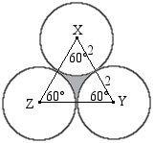CCBBA | CBCAB | CAADE | BDDBC | CCABC | CDCCD

1) **C** 

2) **C** = 4

3) **B** 

4) **B** 







; 1 is extraneous

5) **A** Definition of centroid

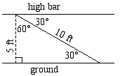6) **C** Create a 30-60-90 triangle

7) **B** We know that ∠XYZ is 66° because it is a corresponding angle with ∠QRT. ∠XZY is 24° by alternate interior angles. ∠QXZ is the supplement of ∠YXZ, which is.

8) **C** A regular dodecagon has 12 equal angles. 360°/12 = 30°

9) **A**  Volume = 

Volume = 

10) **B**

Upon connecting the centers of the circles, we see that △XYZ is equilateral with side length 4. So the area of the shaded region is.

11) **C** II. The contrapositive of a statement is always logically equivalent to the original statement. IV is just a different wording of the original statement.

12) **A** Area of audience: square meters

13) **A**ft

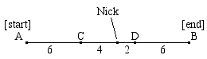14) **D**

15) **E** The wheel’s circumference is 10π.

150/10π ~ 4.77, so 4 complete revolutions.

16) **B** The median is the average of the bases: (6 + 10) / 2 = 8

17) **D** The points can be used to form a 3-4-5 triangle. Alternatively, you can use distance formula:



CCBBA | CBCAB | CAADE | BDDBC | CCABC | CDCCD

18) **D** There are 12 hours on a clock, so the angle formed between two adjacent hours (12:00 and 1:00 in this case) is

360/12 = 30

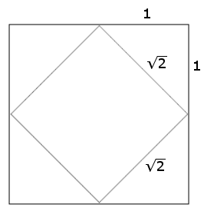19) **B** Using a 45-45-90 triangle, you can find that the side length of the smaller square is, so the area is 2.

20) **C** Let the height of the bag be *x*.





, so 

21) **C** 

22) **C** For a triangle to exist, the sum of any two sides must be greater than the third. 1+2 is not greater than 3; therefore the correct answer is C.

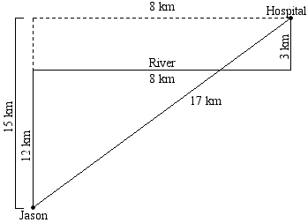23) **A** The shortest path is always a straight line, so reflect the hospital over the river and find the distance using the resulting 8-15-17 right triangle.

24) **B** Arc QR has the same degree measure as ∠QAR, so simply set QR as *x*° and solve.

 , so *x* = 72°

25) **C**   
26) **C** # of diagonals: 

so, diagonals

27) **D** Only the 4x4x4 cube in the interior of the 6x6x6 cube is left completely unpainted.

28) **C** In a 45-45-90, the median is always half of the hypotenuse. This can easily be tested by using.

29) **C** An icosagon is a polygon with 20 sides.

30) **D** Sum of interior angles = 180°(*n*-2)

A hexagon has six sides:

180°(6-2) = 720°